DO ART NCD Tables & Figures

20 September, 2022

## Main paper tables (South Africa only)

* Table 1: Descriptive statistics of cardiovascular risk in the South Africa site of the DO ART study, by trial arm and gender
* Table 2: Poisson + linear regressions for community follow-up compared with clinic follow-up, and including VS
* Table 3: Poisson + linear regressions with VS as predictor, stratified by treatment arm; with interaction term for VS

## Distribution figures (South Africa only)

* Figure 1: CVD variables, comparing VS versus not

### Page Break

## Figure 1: Distribution of clinical CVD measures, by arm [dashed lines are group medians]

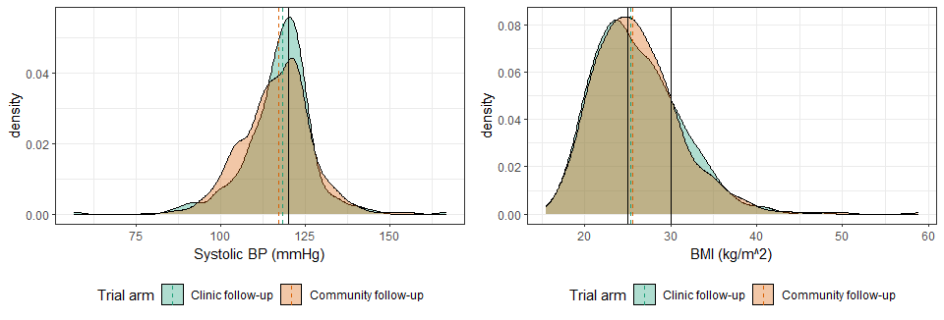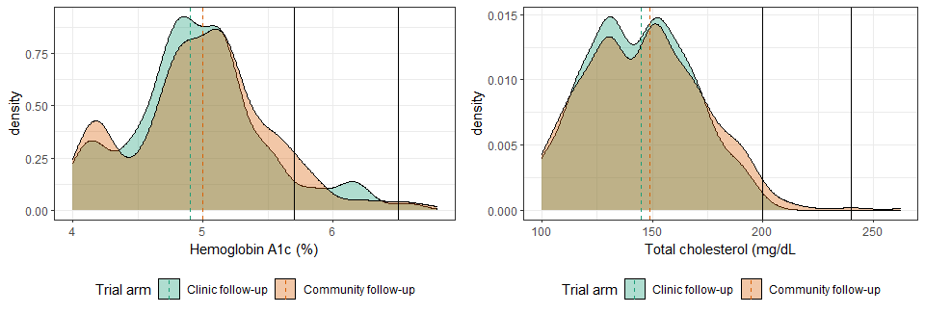

### Page Break

## Figure 2: Distribution, by viral suppression status at endline [dashed lines are group medians]

